**Inheritance**

INHERITANCE in java is a mechanism in which a **child OBJECT acquires all the PROPERTIES and BEHAVIORS of a parent OBJECT**.

INHERITANCE represents the IS-A relationship which is also known as a PARENT-CHILD relationship.

EXAMPLE

EMPLOYEE

^

|

|

PROGRAMMER

As displayed in the above figure, Programmer is the subclass and Employee is the superclass.

The relationship between the two classes is Programmer IS-A Employee.

It means that Programmer is a type of Employee.

USE INHERITANCE IN JAVA

1. for METHOD OVERRIDING (so RUNTIME POLYMORPHISM can be achieved).

2. for CODE REUSABILITY.

TYPES OF INHERITANCE IN JAVA

There are three types of inheritance supported by java class:

1. single

2. multilevel

3. hierarchical

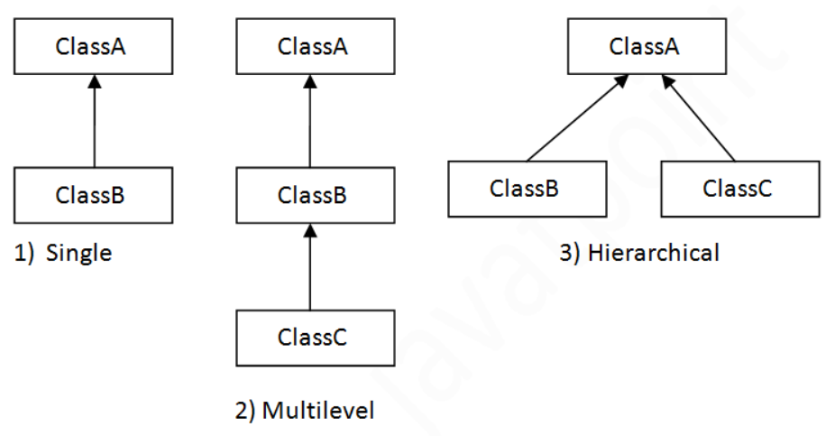

Note:

MULTIPLE inheritance is not supported by java CLASS.

In java, MULTIPLE inheritance is supported only through INTERFACE.

MULTIPLE:

when one class is inherited from 2 or more classes

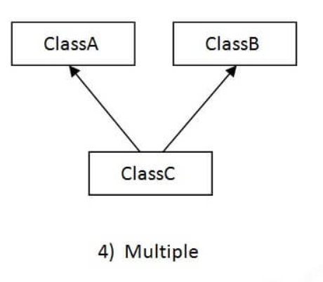

HYBRID:

A hybrid inheritance is a combination of more than one types of inheritance.

Hybrid inheritance may be supported / may not be supported in java class, based on involved inheritances in hybrid inheritance.

If a hybrid inheritance contains multiple inheritance then it will not be supported by java class.

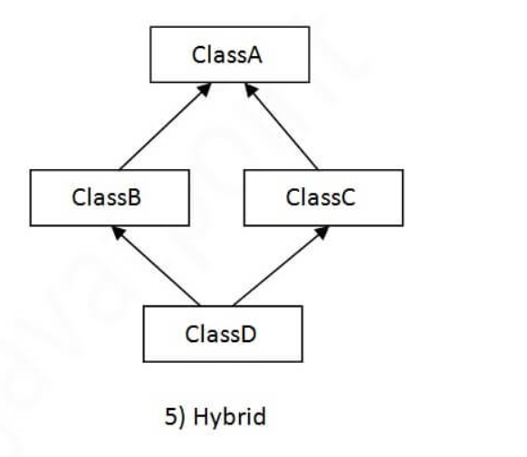

WHY MULTIPLE INHERITANCE IS NOT SUPPORTED IN JAVA ?

To prevent the Ambiguity.

Example:

If a subclass(C) inherited from two parent classes(A & B). A & B have same methods. And if you call the method of parent class from child class object, then there will be ambiguity to call the method of Class A OR B.

SINGLE INHERITANCE

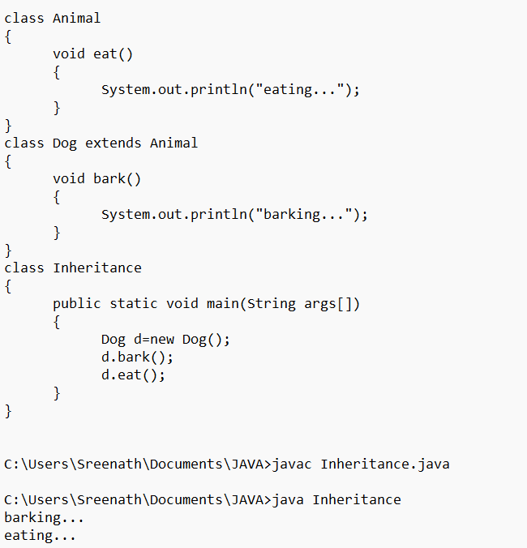

MULTILEVEL INHERITANCE

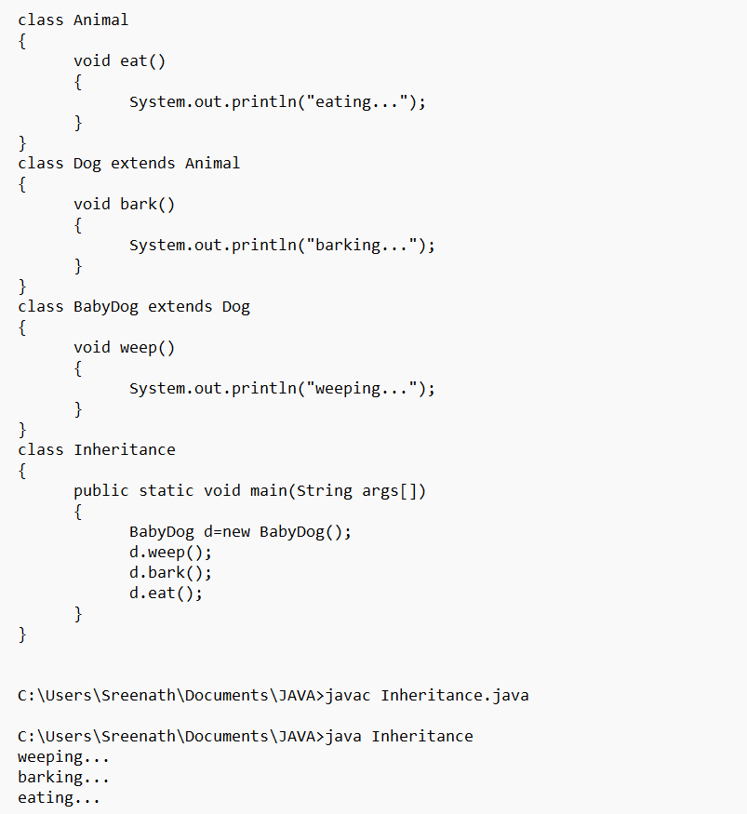

HEIRARCHICAL INHERITANCE

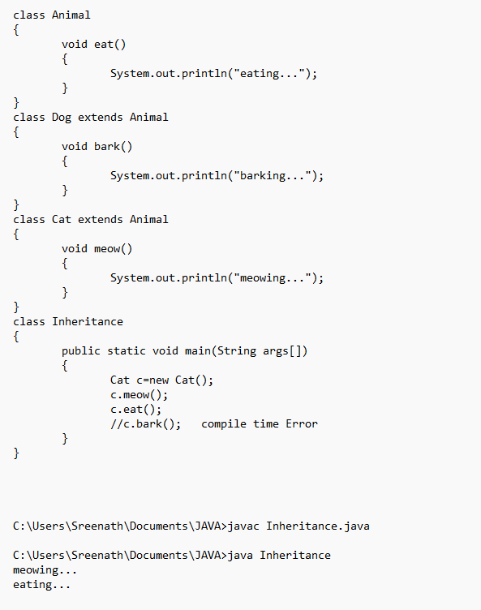

MULTIPLE Inheritance not supported in Java class

~~